Part2 part3 demonstration:

We will have 2 order server replicas running on two different machine:

ORDER_SERVER_0:192.168.85.128

ORDER_SERVER_1:192.168.85.129

We reset the log file of both order server.

Then we start the two order_server and issue a request.

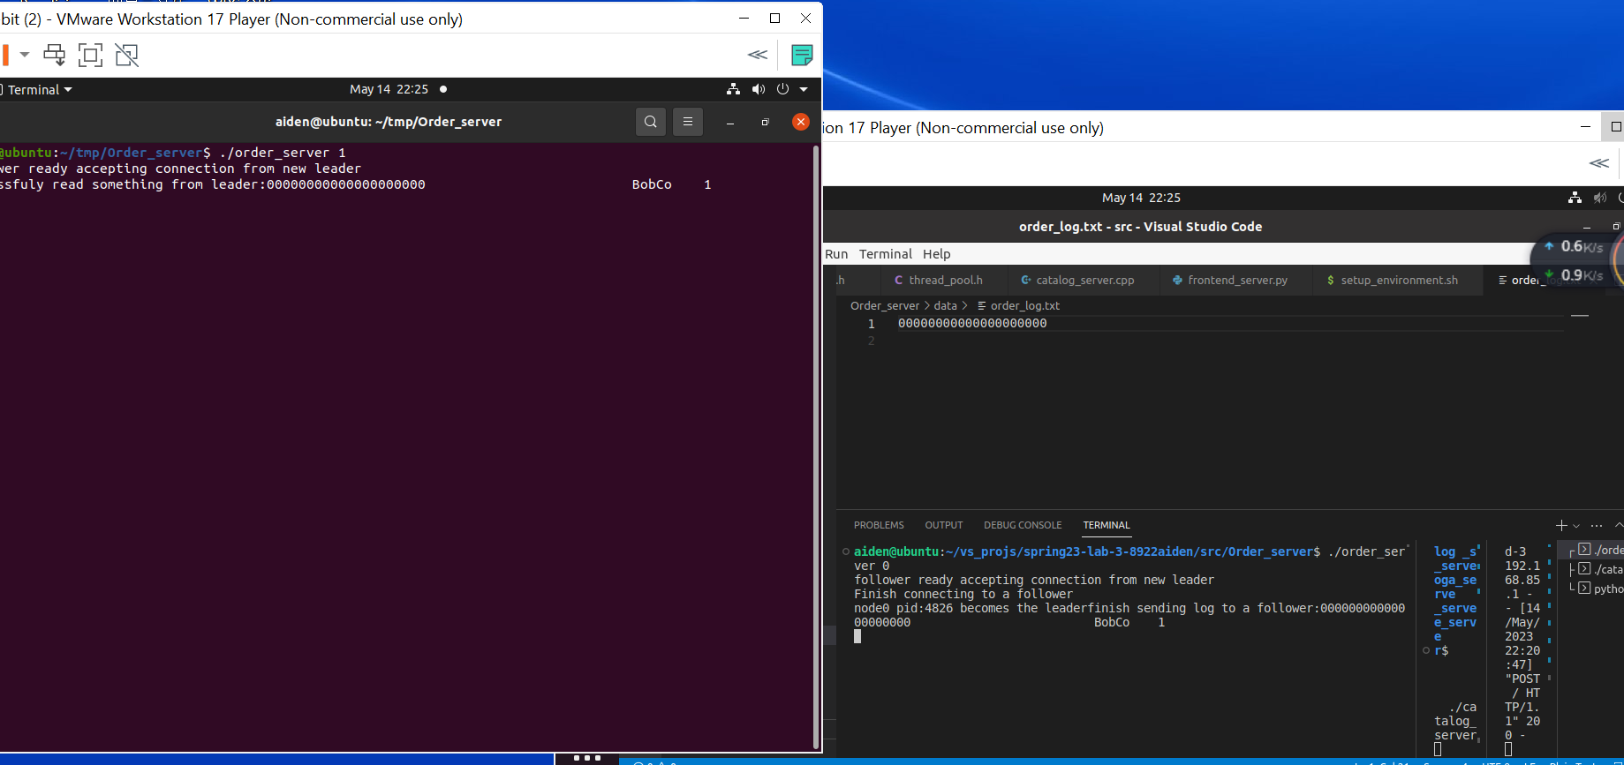

As we can see, order server 0(left)are picked as leader,it receives request from the frontend server and send it to the order_server 1(right).

Next we shut down the order server 1, which is the follower

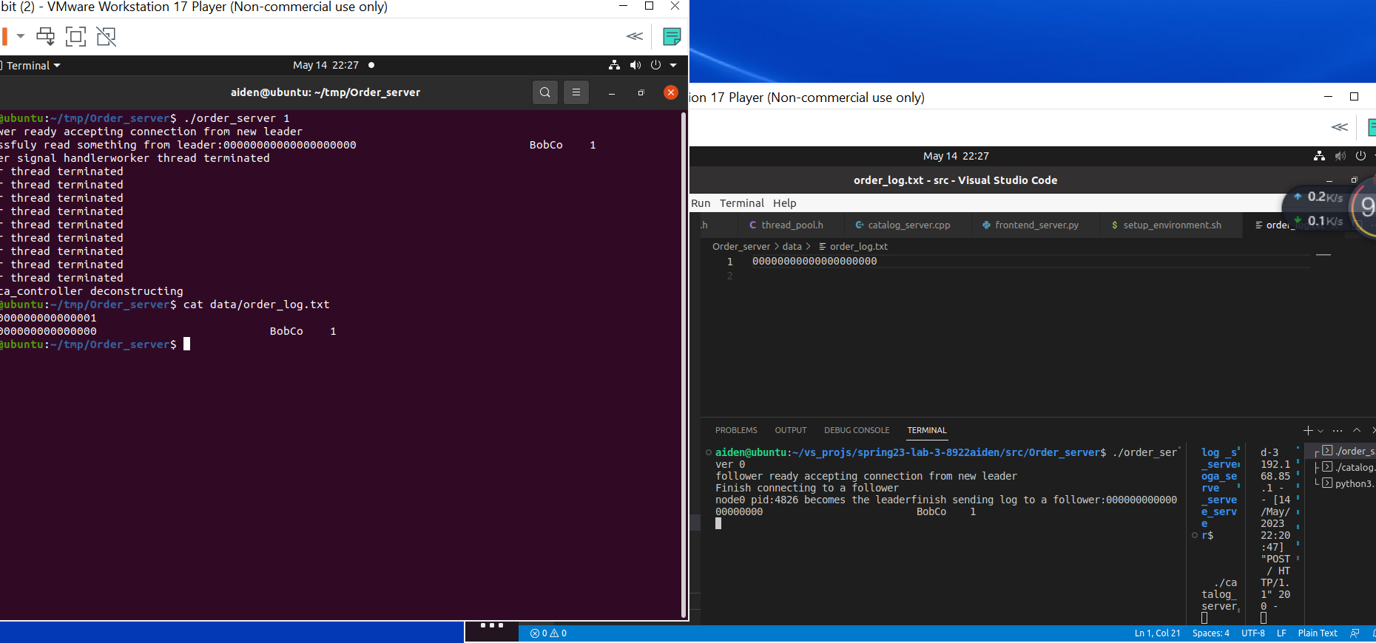

As we can see, the follower’s log file are properly synced. On the other hand, the write to the log file of leader are still cached in the c++ fstream’s buffer, so we won’t be able to see the update inmediately.

Then we continue to send request to the leader to cause a inconsistency.

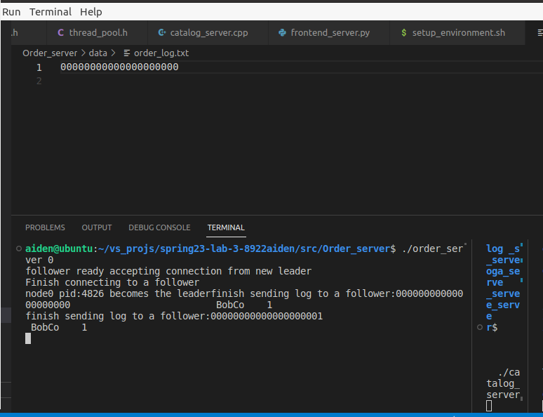

We see although the follower diconnected, the leader’s socket2follower would inmediately perceive the failure of the other side. Even if the leader socket receives fin, it can still send to the other end, but just won’t get any ack, So in this case TCP would only realize the failure of other end either after a while or after a never-got-acked send.

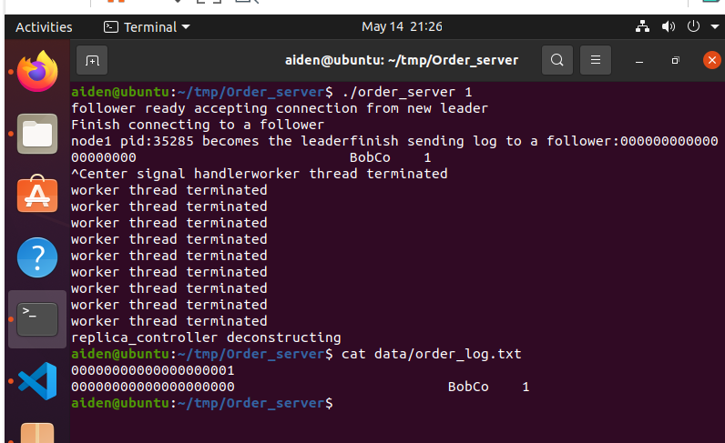

Then we send another request

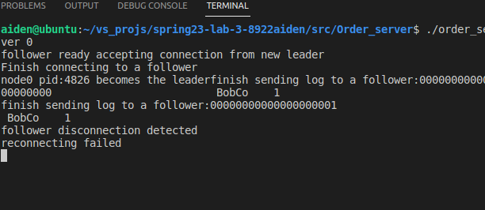

This time the leader detects the disconnection of other end when trying to send updates to follower, it then trys to reconnect. But since we haven’t reboot the server 1 yet, the reconnect will fail with no doubt.

Then we bring up the server 1 again and send another request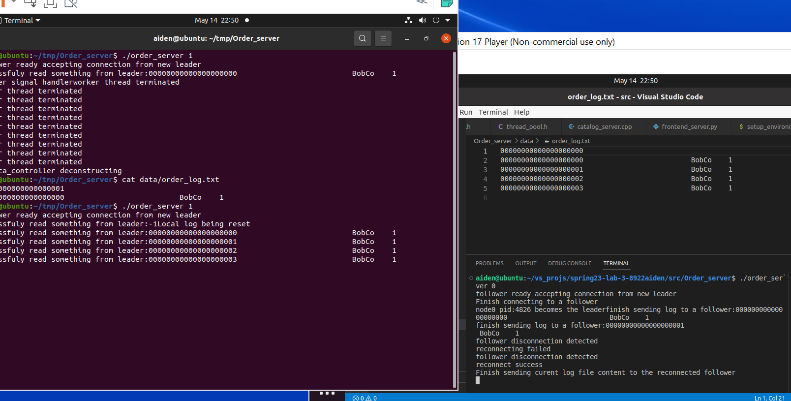

This time we leader detects the failure of follower , it reconnects and succeed. then it will tell follower to reset its log file and send its entire copy of the current log file to that follower.

Then we terminate the leader, which is order server 0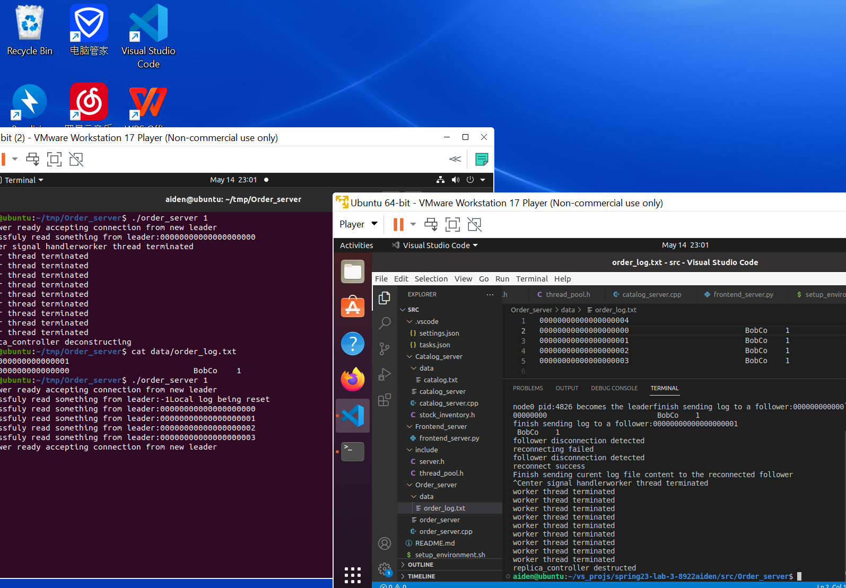

As the leader terminates, its buffered file write will finally be conducted and we can check the log correctness.

Then we send a request to see if it would be affect or not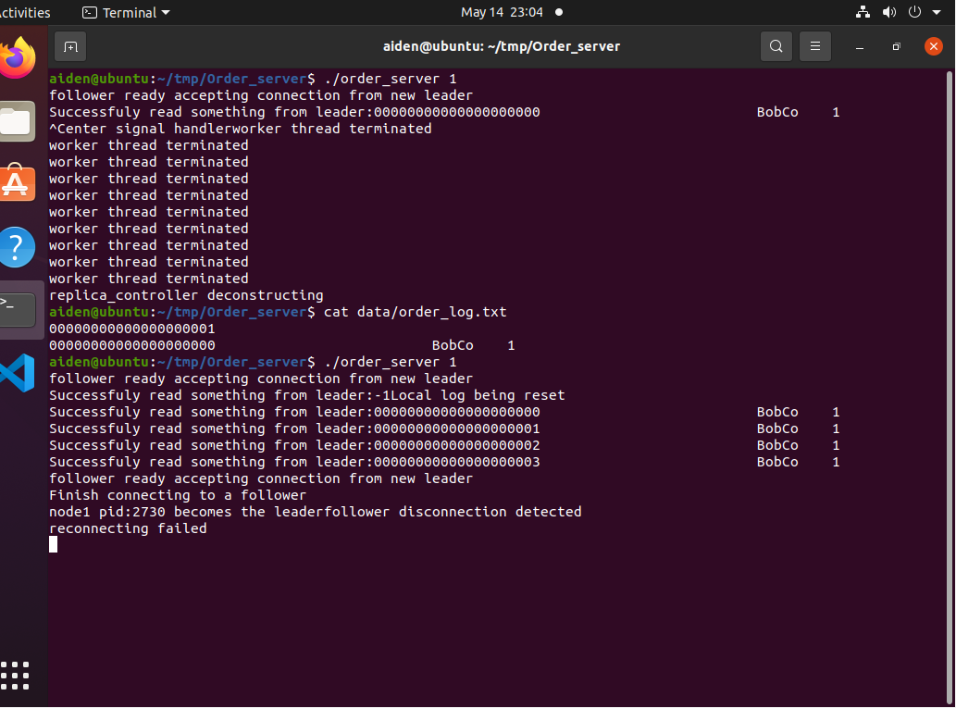

As we can see, the frontend server notice the failure of the current leader, then it select the next replica as the leader, which is order server 1. As server 1 process the request, he trys to send synchronization to order_server 0, but it detects that order server 1 is down. So he trys to reconnect, but since server 1 hasn’t been rebooted yet. The reconnection fails.

The we bring up the server 0 again. And then send a request.

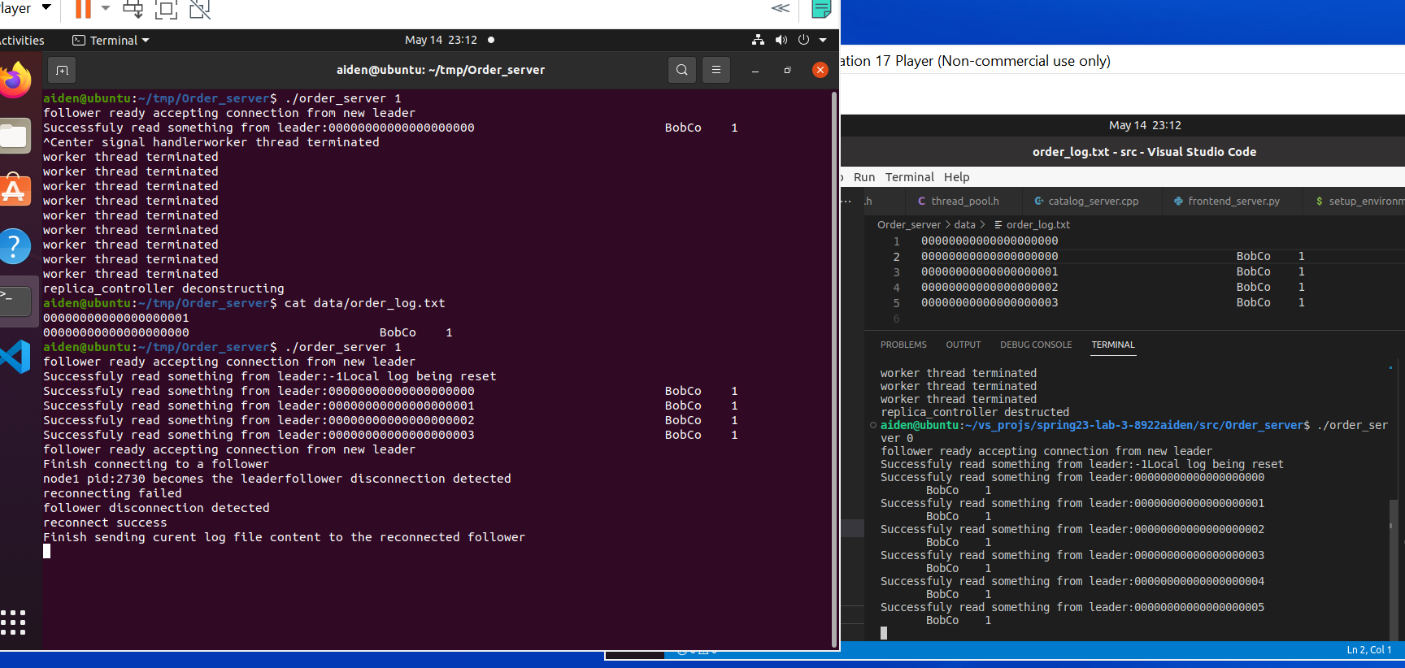

The leader won’t change simple because server 0 comes back. The frontend server will keep send requests to the current leader as long as it are’t die. And as server 1 receive and process the requests, it detects the disconnection of the follower and try to reconnect, and succeed. So it send its entire log file to server 0.

Then we terminate the two order server and check the log 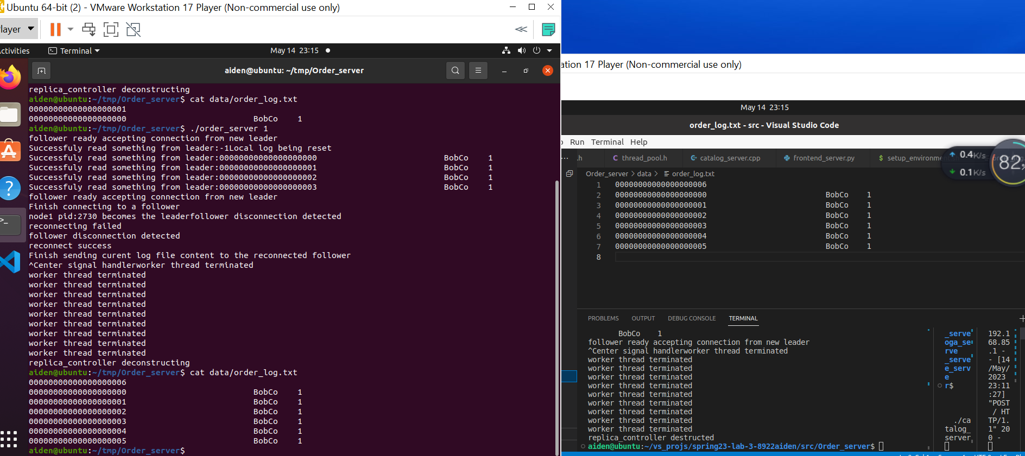

Everything is as expected.

Another thing is as long as at least one order server exists, the request will get dispatched to that server and the user won’t feel any different